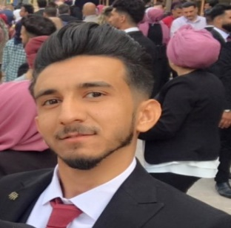 **Zaid raad**

Iraq , Baghdad/ hayi al atibba Area, Adjacent to Airport Road / 07727823438/07802969943 zaidraad1111@gmail.com

Objective

” I recently graduated from the University of Baghdad / Faculty of Management and Economics / Department of Economics 2018. My goal is to seek a chance to appreciate my position and develop my skills, and am very moderate in the "work"

Education

University of Baghdad / administration and Economic / Department of Economic

Bachelor degree

Profile

Skills:

Workunder pressure/team work / I can work any time/ ican relte with others/ communication skills / Using the CLUBS program/crm programe

Computers skills :excel/word outlock

Experience:

I have been work in zain iq company in costumer service costumer care department callcenter agent from 2018/august until now

Training courses:

I have been trained in the Bank byblos for one month in 2017

I holds an English Language Certificate from the British Council 2017

I have certifcateof training from Iraq private banks league

I have train now for HR skills and business administration from course from Stanford university in Iraq space center for training

Languages: Excellent Arabic/excellent English